<http://stats.stackexchange.com/questions/51296/how-do-you-calculate-precision-and-recall-for-multiclass-classification-using-co>

F score=

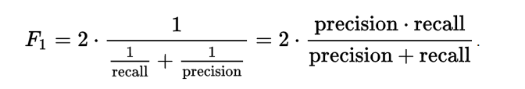

|  |  |
| --- | --- |
| 43down voteaccepted | In a 2-hypothesis case, the confusion matrix is usually:  | Declare H1 | Declare H0 |  |Is H1 | TP | FN |  |Is H0 | FP | TN |  where I've used something similar to your notation:   * TP = true positive (declare H1 when, in truth, H1), * FN = false negative (declare H0 when, in truth, H1), * FP = false positive * TN = true negative   From the raw data, the values in the table would typically be the counts for each occurrence over the test data. From this, you should be able to compute the quantities you need.  *Edit*  The generalization to multi-class problems is to sum over rows / columns of the confusion matrix. Given that the matrix is oriented as above, i.e., that a given row of the matrix corresponds to specific value for the "truth", we have:    That is, precision is the fraction of events where we *correctly* declared ii out of all instances where the algorithm declared ii. Conversely, recall is the fraction of events where we correctly declared iiout of all of the cases where the true of state of the world is ii. |